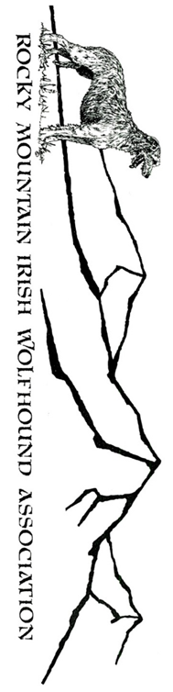
Eleanor Burkley Wetmore Vista Dr.
740 Wetmore Vista Dr.
Florence, CO 81226
407-920-5004(cell)
elleburk@aol.com (email)
Early entries close on
Tuesday, Nov. 24, 2020 at 5:00 p.m.
www.rmiwa.org

PREMIUM LIST

This premium available via email from Field Trial Secretary: elleburk@aol.com
Early entries close on Nov. 19, 2020 at 5:00 p.m. at the FTS’s address
NO DAY OF ENTRIES ALLOWED! ENTRY LIMITS – SEE INSIDE
(Substitutions by the same owner will be allowed by Roll Call the day of the trial)

REGION 3
ASFA SANCTIONED
ALL BREED LURE FIELD TRIALS
November 21st & 22nd

Falcon Institute for Advanced Coursing Studies
16380 Falcon Highway
Peyton, Colorado 80831-7993

Entry Fees:
EARLY ENTRY FEES: $17.00 for 1st entry; $14.00 for 2nd and $12 each additional hound with same owner.
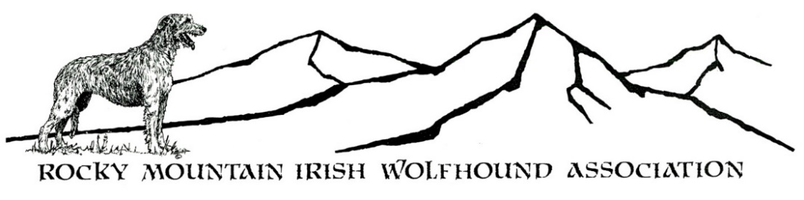
FACIAL COVERINGS WILL BE REQUIRED at all times except when you are around the immediate vicinity of your vehicle (or in your vehicle.) Social distancing of a minimum of 6 feet is required when interacting with members outside your household. REVIEW WAIVER AND PROTOCOLS IN PREMIUM

Payments via PayPal accepted
Please add $2 to the entry fees and send to Treasurer@RMIWA.org
Send a copy of the PayPal receipt along with your entries to the Field Trial Secretary
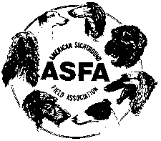
www.asfa.org

Permission has been granted by the American Sighthound Field Association for the holding of this event under American Sighthound Field Association Rules and Regulations.

Audrey Silverstein, Chair, ASFA Scheduling Committee.
ROCKY MOUNTAIN IRISH WOLFHOUND ASSOCIATION www.RMIWA.org
OFFICERS AND DIRECTORS
President: Connie Smalley Treasurer: Amy Solberg
Vice President: Misty Riley Secretary: Sarah Shorey
Board of Directors: Eleanor Burkley, Jody Bryan, Mike Hussey, Denise Shorey

JUDGES and their assignments
Deann Britton Aurora, CO
Frank Cassano LaSalle, CO
Tom Golcher Peyton, CO
Darci Kunard Reunion, CO
Pete Lowe Falcon, CO
Claudia Miller Arvada, CO
S = Single Judge * = Provisional Judge # = Canadian Judge
SATURDAY
Judge | A | Az | Ba | B | C | G | Ib | IW | IG | P | RR | S | SD | SW | Sl | W | Sing | Ltd
Deann |  |  |  | x | x | x | x | x | x | x | x | x | x | x | x
Frank | x | x | x | x | x | x | x | x | x |  |  |  |  |  |  | x | x | x
Tom | x | x | x |  |  |  |  |  |  | x | x | x | x | x | x | x | x | x
SUNDAY
Judge | A | Az | Ba | B | C | G | Ib | IW | IG | P | RR | S | SD | SW | Sl | W | Sing | Ltd
Darci | x | x | x | x | x | x | x | x |  |  |  | x | x | x | x | x | x | x
Pete | x | x | x | x | x | x | x |  | x | x | x
Claudia |  |  |  |  |  |  |  | x | x | x | x | x | x | x | x | x | x | x

TRIAL HOURS 7:30 am until completed
Day of trial entries close at the start of Roll Call Roll call: 9:00 am
FIELD COMMITTEE
Field Chairman Michael Hussey (303) 549-5584 (cell) dinnree@skybeam.com
Field Secretary Eleanor Burkley, 740 Wetmore Vista Dr, Florence, CO 81226
elleburk@aol.com 407-920-5004(cell)
Lure Operators Tom Golcher, Mike Hussey, Leonard Luty, Connie Sullivan

RIBBON PRIZES Placements: 1st Blue, 2nd Red, 3rd Yellow, 4th White, NBQ Green
Best of Breed: Purple & Gold Rosette Highest Scoring Single: Navy/Gold

LIST OF BREEDS ELIGIBLE TO ENTER: Only purebred Afghan Hounds, Azawakhs, Basenjis, Borzoi, Cirneco dell’Etna, Greyhounds, Ibizan Hounds, Irish Wolfhounds, Italian Greyhounds, Pharaoh Hounds, Rhodesian Ridgebacks, Salukis, Scottish Deerhounds, Silken Windhounds, Sloughis, Whippets may be entered in the regular stakes. Limited stake breeds, if any, may be entered in the Limited Stake. These are listed on the ASFA website. All entries in the regular stakes shall be individually registered with the American Kennel Club, the National Greyhound Association, the Federation Cynologique Internationale, an ASFA-recognized foreign or ASFA Board approved registry, or possess a critique registration number (CRN) from the Society for the Perpetuation of Desert Bred Salukis (SPDBS). Limited and/or Provisional stake entries shall be individually registered with the appropriate registry. (Dogs with an Indefinite Listing Privilege (ILP) or Purebred Alternate Listing (PAL) from the American Kennel Club shall be considered registered with that body.)” ENTRIES WILL NOT BE ACKNOWLEDGED BY MAIL OR TELEPHONE. LATE, INCOMPLETE, UNSIGNED OR CONDITIONAL ENTRIES WILL NOT BE ACCEPTED.
REFUND POLICY: Refunds will be allowed for lame hounds, bitches in season and breed disqualifications as determined at the trial inspection. Full refunds are allowed for entries cancelled for ANY reason prior to the Entry Closing Date and Time.
NO REFUNDS AFTER THE EARLY CLOSING TIME EXCEPT FOR THE REASONS LISTED ABOVE

STAKES OFFERED
OPEN STAKE: Any eligible sighthound, excluding ASFA Field Champions of record that have met certification requirements.
FIELD CHAMPION STAKE: Any ASFA Field Champion.
VETERAN STAKE: Any eligible sighthound which is 6 years or older on the day of the trial, except Irish Wolfhounds whose age shall be 5 years; and Afghans, Rhodesian Ridgebacks, Salukis, and Whippets whose age shall be at least 7 years of age and has met ASFA Regional Invitational requirements. Points go toward V-FCh and V-LCM.
LIMITED STAKE: Any eligible sighthound of a Limited or Provisional stake breed that has met certification requirements. Not eligible to compete in Best of Breed or Best in Field.
SINGLE STAKE: Any eligible sighthound including those disqualified to run in other stakes. Not eligible to compete in Best of Breed or Best in Field.
BEST IN FIELD WILL NOT BE OFFERED

Conditions of Entry:
All entries must be one year or older on the day of the trial. Stakes will be split into flights by public random draw if the entry in any regular stake is 20 or more. Bitches in season, lame hounds and hounds with breed disqualifications will be excused at roll call. Spayed, neutered, monorchid or cryptorchid hounds without breed disqualifications may be entered. Hounds with breed disqualifications are not eligible to enter except in the Single Stake. Hounds not present at the time of roll call will be scratched. All hounds will run twice, in trios if possible or braces (except in the Single Stake), unless excused, dismissed or disqualified.
All Hounds entering Open, Veteran or Limited Stakes for the first time MUST include a completed ASFA Certification Form or Waiver Form (with proof of coursing title) and a copy of the hound’s registration certificate (registration proof waived for NGA Greyhounds only; ASFA certification waived for Single Stake entries only).
Equipment:
Battery powered continuous loop machine will be used. Lure will consist of white plastic strips or a combination of black and white plastic strips. Back-up equipment will be available.

General Information
BRING WATER AND SHADE FOR YOUR HOUNDS. Porta-potty on site.
WARNING: Due to the altitude and some natural terrain of the course all hounds entered must be in top physical condition. ALL HOUNDS RUN AT THE OWNER’S SOLE RISK. The majority of the courses will be run on mowed groomed grass.

Practice and Certifications
Certifications offered each day after the completion of the trial Cost $7.00 per dog. No charge for RMIWA Members. Owners of certifying dog are responsible for arranging another hound of the same breed (or another breed with a similar running style).
Practice will be held following the trial on Saturday only (weather and equipment conditions permitting) $5.00 per hound. No charge for RMIWA Members. Any breed may practice.
COURSE PLANS (to scale): Course will be reversed for finals and again for run-offs or at the discretion of the judges. The RMIWA reserves the right to alter the course diagram as required by weather and/or field conditions on the day of the trial.

Saturday 770 yards

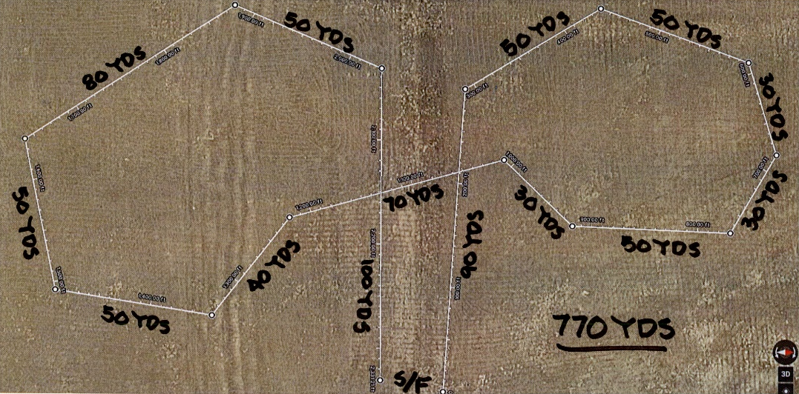

Sunday 7600 yards

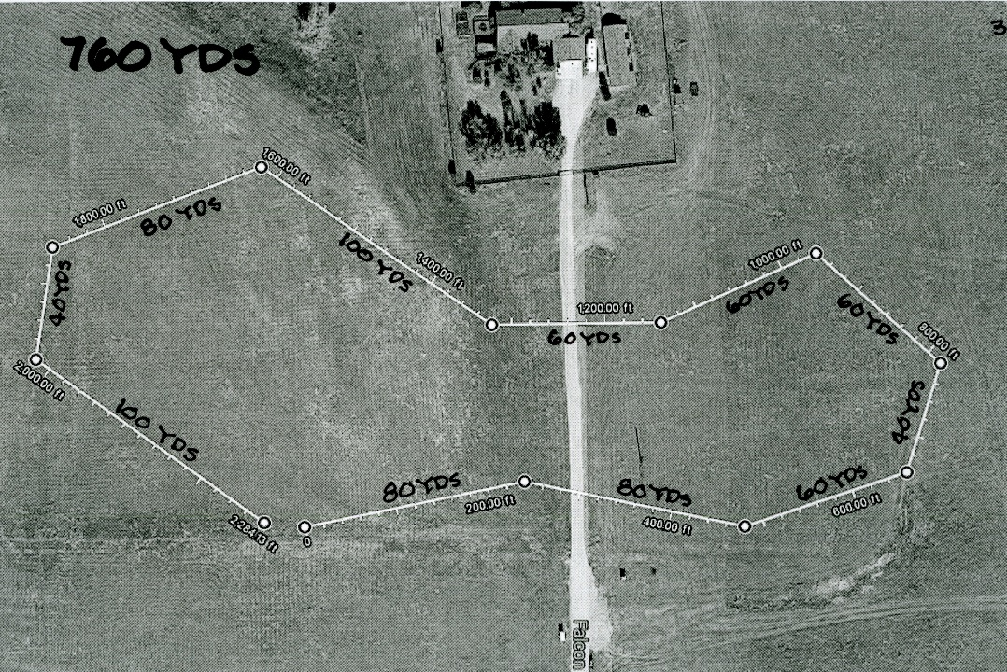

Information & Policies
• Port-a-pot on site.
• BRING WATER AND SHADE FOR YOUR HOUNDS.
• Bring FOOD – none offer by the Club.
• Veterinarian – Friday and Saturday – Black Forest
Veterinary Clinic 719-495-3666. Sunday Animal
Emergency Care, 5752 North Academy Blvd., (behind
Petco) 719-260-7141.
• Due to dry conditions, smoking of any kind is prohibited on the field,
Absolutely NO CAMPFIRES!
• PICK UP AFTER YOUR DOG AND YOURSELF!
• EQUIPMENT: Type of lure machine: battery-powered continuousloop system. Back-up equipment will be available. Type of lures:
highly visible plastic strips.
• A $20.00 fee will be assessed for any returned checks. Persons
exhibiting conduct detrimental to ASFA/CLCA/ any hound(s)/other
person(s) will be asked to leave the trial site.
• There will be a $5.00 fine for any owner who does not clean up after
his/her hound and for any loose hound not competing in the course
in progress.

ADVISEMENTS – PLEASE READ
• Falcon, Colorado is at a high-altitude (6800 ft above sea
level.) This is considered the high desert.
• Due to the high altitude, please ensure your hounds AND you
are in top physical condition.
• Sunscreen and lots of water are strongly recommended.
• The field is NATURAL TERRAIN tending to be dry, uneven
ground with a few patches of prairie plants, cactus,
goatheads, and some rocks. The field is mowed prior to the
trial. Care is taken to remove rocks and cactus from the path
of the lure. This is NOT a manicured lawn.
• The ground can be hard, packed dirt depending on whether it
has rained recently. Sandy soil is also present
• Be sure to check your dog’s feet frequently for cactus,
goatheads, and the condition of their pads.
• You and your dogs will NEED more water than you think is
normal due to the altitude, dry conditions and lack of
humidity.
• We do our best to patch holes in the ground from the various
wildlife; as well as remove cactus and rocks from the path of
the lure. Participants are encouraged to help walk the field
BEFORE the trial to patch holes.
• October can be warm, hot, mild, raining, or snowing. Please
be prepared for any/all types of weather.

OFFICIAL AMERICAN SIGHTHOUND FIELD ASSOCIATION ENTRY FORM

ROCKY MOUNTAIN IRISH WOLFHOUND ASSOCIATION
SATURDAY November 21, 2020
ASFA Sanctioned Lure Field Trial
Entries close Thursday. November 19 at 5:00 p.m.
$17.00 for 1st dog, $14.00 2nd dog, $12.00 ea. add’l dog same owner.
PAYPAL payments accepted. See instructions on cover page.
Make checks payable in US funds to RMIWA and mail with entry to:
Eleanor Burkley, 740 Wetmore Dr., Florence, CO 80226
Fee Paid ______The Field Secretary cannot accept conditional, unsigned, incomplete or unpaid entries; please check your completed entry carefully.

Breed: | Call Name:
Registered Name of Hound:

Stake  Open FCH Veteran Single Limited |  | Additional Stakes:  Kennel Breeder Bench
Registration Number: (please write in registering body before number)

If possible, please  separate my hounds | Date of  Birth: | Sex:  Dog Bitch
Name of actual owner(s):

Address: |  | Phone:
City: |  | State: | Zip:
E-Mail (Optional): |  | (Optional) Region of Residence:
Check if this is the first ASFA trial for this hound. Attach a Hound Certification or waiver if entered in Open, Veterans, Limited.
Check if this is a first time entry, a copy of the official Registration of this hound must accompany this entry unless NGA.
Check if any information has changed since the last ASFA trial entry. Regarding
Check if this hound has been dismissed within the last 6 trials entered. Must be marked in order to qualify for a “clean” trial requirement.
I CERTIFY that I am the actual owner of this dog, or that I am the duly authorized agent of the actual owner whose name I have entered above. In consideration of the acceptance of this entry and the opportunity to have this dog judged and to win prize money, ribbons, or trophies, I (we) agree to abide by the rules and regulations of the American Sighthound Field Association in effect at the time of this lure field trial, and by any additional rules and regulations appearing in the premium list for this lure field trial. I (we) agree that the club holding this lure field trial has the right to refuse this entry for cause, which the club shall deem to be sufficient. I (we) agree to hold this club, its members, directors, governors, officers, agents or other functionaries, any employees of the aforementioned parties and the owner(s) of the trial premises or grounds harmless from any claim for loss or injury which may be alleged to have been caused directly or indirectly to any person or thing by the act of this dog while in or upon the lure field trial premises or grounds or near any entrance thereto and I (we) personally assume all responsibility and liability for any such claim, and I (we) further agree to hold the aforementioned parties harmless from any claim loss of this dog by disappearance, theft damage or injury be caused or alleged to be caused by the negligence of the club or any of the aforementioned parties or by the negligence of any person or any other cause or causes. I (we) certify and represent that the dog entered is not a hazard to person or other dogs. This entry is submitted for acceptance of the forgoing representations and agreements.

SIGNATURE of owner or his agent
duly authorized to make this entry ___________________________________________________________________
EF-A ~ rev 07-12
OFFICIAL AMERICAN SIGHTHOUND FIELD ASSOCIATION ENTRY FORM

ROCKY MOUNTAIN IRISH WOLFHOUND ASSOCIATION
SATURDAY November 21 2020
ASFA Sanctioned Lure Field Trial
Entries close Thursday. November 19 at 5:00 p.m.
$17.00 for 1st dog, $14.00 2nd dog, $12.00 ea. add’l dog same owner.
PAYPAL payments accepted. See instructions on cover page.
Make checks payable in US funds to RMIWA and mail with entry to:
Eleanor Burkley, 740 Wetmore Dr., Florence, CO 80226
Fee Paid ______The Field Secretary cannot accept conditional, unsigned, incomplete or unpaid entries; please check your completed entry carefully.

Breed: | Call Name:
Registered Name of Hound:

Stake  Open FCH Veteran Single Limited |  | Additional Stakes:  Kennel Breeder Bench
Registration Number: (please write in registering body before number)

If possible, please  separate my hounds | Date of  Birth: | Sex:  Dog Bitch
Name of actual owner(s):

Address: |  | Phone:
City: |  | State: | Zip:
E-Mail (Optional): |  | (Optional) Region of Residence:
Check if this is the first ASFA trial for this hound. Attach a Hound Certification or waiver if entered in Open, Veterans, Limited.
Check if this is a first time entry, a copy of the official Registration of this hound must accompany this entry unless NGA.
Check if any information has changed since the last ASFA trial entry. Regarding
Check if this hound has been dismissed within the last 6 trials entered. Must be marked in order to qualify for a “clean” trial requirement.
I CERTIFY that I am the actual owner of this dog, or that I am the duly authorized agent of the actual owner whose name I have entered above. In consideration of the acceptance of this entry and the opportunity to have this dog judged and to win prize money, ribbons, or trophies, I (we) agree to abide by the rules and regulations of the American Sighthound Field Association in effect at the time of this lure field trial, and by any additional rules and regulations appearing in the premium list for this lure field trial. I (we) agree that the club holding this lure field trial has the right to refuse this entry for cause, which the club shall deem to be sufficient. I (we) agree to hold this club, its members, directors, governors, officers, agents or other functionaries, any employees of the aforementioned parties and the owner(s) of the trial premises or grounds harmless from any claim for loss or injury which may be alleged to have been caused directly or indirectly to any person or thing by the act of this dog while in or upon the lure field trial premises or grounds or near any entrance thereto and I (we) personally assume all responsibility and liability for any such claim, and I (we) further agree to hold the aforementioned parties harmless from any claim loss of this dog by disappearance, theft damage or injury be caused or alleged to be caused by the negligence of the club or any of the aforementioned parties or by the negligence of any person or any other cause or causes. I (we) certify and represent that the dog entered is not a hazard to person or other dogs. This entry is submitted for acceptance of the forgoing representations and agreements.

SIGNATURE of owner or his agent
duly authorized to make this entry ___________________________________________________________________
EF-A ~ rev 07-12
OFFICIAL AMERICAN SIGHTHOUND FIELD ASSOCIATION ENTRY FORM

ROCKY MOUNTAIN IRISH WOLFHOUND ASSOCIATION
SUNDAY November 22, 2020
ASFA Sanctioned Lure Field Trial
Entries close Thursday. November 19 at 5:00 p.m.
$17.00 for 1st dog, $14.00 2nd dog, $12.00 ea. add’l dog same owner.
PAYPAL payments accepted. See instructions on cover page.
Make checks payable to RMIWA and mail with entry to:
Eleanor Burkley, 740 Wetmore Dr., Florence, CO 80226
Fee Paid _______The Field Secretary cannot accept conditional, unsigned, incomplete or unpaid entries; please check your completed entry carefully.

Breed: | Call Name:
Registered Name of Hound:

Stake  Open FCH Veteran Single Limited |  | Additional Stakes:  Kennel Breeder Bench
Registration Number: (please write in registering body before number)

If possible, please  separate my hounds | Date of  Birth: | Sex:  Dog Bitch
Name of actual owner(s):

Address: |  | Phone:
City: |  | State: | Zip:
E-Mail (Optional): |  | (Optional) Region of Residence:
Check if this is the first ASFA trial for this hound. Attach a Hound Certification or waiver if entered in Open, Veterans, Limited.
Check if this is a first time entry, a copy of the official Registration of this hound must accompany this entry unless NGA.
Check if any information has changed since the last ASFA trial entry. Regarding
Check if this hound has been dismissed within the last 6 trials entered. Must be marked in order to qualify for a “clean” trial requirement.
I CERTIFY that I am the actual owner of this dog, or that I am the duly authorized agent of the actual owner whose name I have entered above. In consideration of the acceptance of this entry and the opportunity to have this dog judged and to win prize money, ribbons, or trophies, I (we) agree to abide by the rules and regulations of the American Sighthound Field Association in effect at the time of this lure field trial, and by any additional rules and regulations appearing in the premium list for this lure field trial. I (we) agree that the club holding this lure field trial has the right to refuse this entry for cause, which the club shall deem to be sufficient. I (we) agree to hold this club, its members, directors, governors, officers, agents or other functionaries, any employees of the aforementioned parties and the owner(s) of the trial premises or grounds harmless from any claim for loss or injury which may be alleged to have been caused directly or indirectly to any person or thing by the act of this dog while in or upon the lure field trial premises or grounds or near any entrance thereto and I (we) personally assume all responsibility and liability for any such claim, and I (we) further agree to hold the aforementioned parties harmless from any claim loss of this dog by disappearance, theft damage or injury be caused or alleged to be caused by the negligence of the club or any of the aforementioned parties or by the negligence of any person or any other cause or causes. I (we) certify and represent that the dog entered is not a hazard to person or other dogs. This entry is submitted for acceptance of the forgoing representations and agreements.

SIGNATURE of owner or his agent
duly authorized to make this entry ___________________________________________________________________
EF-A ~ rev 07-12
OFFICIAL AMERICAN SIGHTHOUND FIELD ASSOCIATION ENTRY FORM

ROCKY MOUNTAIN IRISH WOLFHOUND ASSOCIATION
SUNDAY November 22, 2020
ASFA Sanctioned Lure Field Trial
Entries close Thursday. November 19 at 5:00 p.m.
$17.00 for 1st dog, $14.00 2nd dog, $12.00 ea. add’l dog same owner.
PAYPAL payments accepted. See instructions on cover page.
Make checks payable to RMIWA and mail with entry to:
Eleanor Burkley, 740 Wetmore Dr., Florence, CO 80226
Fee Paid _____The Field Secretary cannot accept conditional, unsigned, incomplete or unpaid entries; please check your completed entry carefully.

Breed: | Call Name:
Registered Name of Hound:

Stake  Open FCH Veteran Single Limited |  | Additional Stakes:  Kennel Breeder Bench
Registration Number: (please write in registering body before number)

If possible, please  separate my hounds | Date of  Birth: | Sex:  Dog Bitch
Name of actual owner(s):

Address: |  | Phone:
City: |  | State: | Zip:
E-Mail (Optional): |  | (Optional) Region of Residence:
Check if this is the first ASFA trial for this hound. Attach a Hound Certification or waiver if entered in Open, Veterans, Limited.
Check if this is a first time entry, a copy of the official Registration of this hound must accompany this entry unless NGA.
Check if any information has changed since the last ASFA trial entry. Regarding
Check if this hound has been dismissed within the last 6 trials entered. Must be marked in order to qualify for a “clean” trial requirement.
I CERTIFY that I am the actual owner of this dog, or that I am the duly authorized agent of the actual owner whose name I have entered above. In consideration of the acceptance of this entry and the opportunity to have this dog judged and to win prize money, ribbons, or trophies, I (we) agree to abide by the rules and regulations of the American Sighthound Field Association in effect at the time of this lure field trial, and by any additional rules and regulations appearing in the premium list for this lure field trial. I (we) agree that the club holding this lure field trial has the right to refuse this entry for cause, which the club shall deem to be sufficient. I (we) agree to hold this club, its members, directors, governors, officers, agents or other functionaries, any employees of the aforementioned parties and the owner(s) of the trial premises or grounds harmless from any claim for loss or injury which may be alleged to have been caused directly or indirectly to any person or thing by the act of this dog while in or upon the lure field trial premises or grounds or near any entrance thereto and I (we) personally assume all responsibility and liability for any such claim, and I (we) further agree to hold the aforementioned parties harmless from any claim loss of this dog by disappearance, theft damage or injury be caused or alleged to be caused by the negligence of the club or any of the aforementioned parties or by the negligence of any person or any other cause or causes. I (we) certify and represent that the dog entered is not a hazard to person or other dogs. This entry is submitted for acceptance of the forgoing representations and agreements.

SIGNATURE of owner or his agent
duly authorized to make this entry ___________________________________________________________________
EF-A ~ rev 07-12

AMERICAN SIGHTHOUND FIELD ASSOCIATION  HOUND CERTIFICATION  Rule effective October 1, 1994: Ch. V, Sec. 4 (a) OPEN STAKE: To be eligible to enter the open stake, a hound must have been certified by a licensed judge within the year preceding the closing date for the entry or have previously competed in the Open Stake. This eligibility requirement also applies to a hound entered in the Limited or Veteran Stake, which has not competed in Open previously. Please complete this portion of this form and attach it to the entry form for the hound’s first entry, including an entry for a Fun Trial.  Registered Name of Hound:  Registration Number: _________________________ Breed:  Registered Owner’s Name:  I hereby certify that on (date) __________________, the above named hound completed a lure course of at least 500 yards, running with another hound of the same breed (or another breed with a similar running style). During the course the above named hound showed no inclination to interfere with the other hound. I further certify that I am a licensed judge for the ASFA.  Name of Licensed Judge:  Signature: Date:  I hereby certify that the hound running in the certification course is the hound identified above and that information provided on this form is true and correct.  Signature: Date:  Owner or Authorized Agent of Hound  This certification form must be attached to the entry form the first time this hound is entered in an open, limited, or veteran stake. Any hound entered in open, limited, or veteran (as a first time entered hound), which has not been certified, shall be declared ineligible by the records coordinator and shall forfeit any points and placements awarded.  PLEASE RETAIN A COPY FOR YOUR RECORDS.  AMERICAN SIGHTHOUND FIELD ASSOCIATION  HOUND CERTIFICATION WAIVER  Waiver of Requirement: This requirement will be waived for a hound that has earned a lure coursing title from another recognized organization, if such title requires competition, and if a waiver for such title has been approved by the ASFA, or a CKC Hound Certification Form. If your hound qualifies for a waiver, complete this portion of this form and attach it to your entry form. Proof of waivers must accompany this certification form.  Registered Name of Hound:  Registration Number: _________________________ Breed:  Registered Owner’s Name:  CKC: FCH FCHX  AKC: QC SC FC  Hound Certification previously submitted.  I hereby certify that the hound identified above has completed the requirements for the title indicated above (or that the required Certification was previously submitted) and that the information provided on this form is true and correct.  Signature: _______________________________________________ Date:  Owner or Authorized Agent of Hound |  | AMERICAN SIGHTHOUND FIELD ASSOCIATION  HOUND CERTIFICATION  Rule effective October 1, 1994: Ch. V, Sec. 4 (a) OPEN STAKE: To be eligible to enter the open stake, a hound must have been certified by a licensed judge within the year preceding the closing date for the entry or have previously competed in the Open Stake. This eligibility requirement also applies to a hound entered in the Limited or Veteran Stake, which has not competed in Open previously. Please complete this portion of this form and attach it to the entry form for the hound’s first entry, including an entry for a Fun Trial.  Registered Name of Hound:  Registration Number: _________________________ Breed:  Registered Owner’s Name:  I hereby certify that on (date) __________________, the above named hound completed a lure course of at least 500 yards, running with another hound of the same breed (or another breed with a similar running style). During the course the above named hound showed no inclination to interfere with the other hound. I further certify that I am a licensed judge for the ASFA.  Name of Licensed Judge:  Signature: Date:  I hereby certify that the hound running in the certification course is the hound identified above and that information provided on this form is true and correct.  Signature: Date:  Owner or Authorized Agent of Hound  This certification form must be attached to the entry form the first time this hound is entered in an open, limited, or veteran stake. Any hound entered in open, limited, or veteran (as a first time entered hound), which has not been certified, shall be declared ineligible by the records coordinator and shall forfeit any points and placements awarded.  PLEASE RETAIN A COPY FOR YOUR RECORDS.  AMERICAN SIGHTHOUND FIELD ASSOCIATION  HOUND CERTIFICATION WAIVER  Waiver of Requirement: This requirement will be waived for a hound that has earned a lure coursing title from another recognized organization, if such title requires competition, and if a waiver for such title has been approved by the ASFA, or a CKC Hound Certification Form. If your hound qualifies for a waiver, complete this portion of this form and attach it to your entry form. Proof of waivers must accompany this certification form.  Registered Name of Hound:  Registration Number: _________________________ Breed:  Registered Owner’s Name:  CKC: FCH FCHX  AKC: QC SC FC  Hound Certification previously submitted.  I hereby certify that the hound identified above has completed the requirements for the title indicated above (or that the required Certification was previously submitted) and that the information provided on this form is true and correct.  Signature: _______________________________________________ Date:  Owner or Authorized Agent of Hound
Sec-06 rev 02/19©
AMERICAN SIGHTHOUND FIELD ASSOCIATION
HOUND CERTIFICATION
Rule effective October 1, 1994: Ch. V, Sec. 4 (a) OPEN STAKE: To be eligible to enter the open stake, a hound must have been certified by a licensed judge within the year preceding the closing date for the entry or have previously competed in the Open Stake. This eligibility requirement also applies to a hound entered in the Limited or Veteran Stake, which has not competed in Open previously. Please complete this portion of this form and attach it to the entry form for the hound’s first entry, including an entry for a Fun Trial.
Registered Name of Hound:
Registration Number: _________________________ Breed:
Registered Owner’s Name:
I hereby certify that on (date) __________________, the above named hound completed a lure course of at least 500 yards, running with another hound of the same breed (or another breed with a similar running style). During the course the above named hound showed no inclination to interfere with the other hound. I further certify that I am a licensed judge for the ASFA.
Name of Licensed Judge:
Signature: Date:
I hereby certify that the hound running in the certification course is the hound identified above and that information provided on this form is true and correct.
Signature: Date:
Owner or Authorized Agent of Hound
This certification form must be attached to the entry form the first time this hound is entered in an open, limited, or veteran stake. Any hound entered in open, limited, or veteran (as a first time entered hound), which has not been certified, shall be declared ineligible by the records coordinator and shall forfeit any points and placements awarded.

PLEASE RETAIN A COPY FOR YOUR RECORDS.
AMERICAN SIGHTHOUND FIELD ASSOCIATION
HOUND CERTIFICATION WAIVER

Waiver of Requirement: This requirement will be waived for a hound that has earned a lure coursing title from another recognized organization, if such title requires competition, and if a waiver for such title has been approved by the ASFA, or a CKC Hound Certification Form. If your hound qualifies for a waiver, complete this portion of this form and attach it to your entry form. Proof of waivers must accompany this certification form.

Registered Name of Hound:
Registration Number: _________________________ Breed:
Registered Owner’s Name:
CKC: FCH FCHX
AKC: QC SC FC
Hound Certification previously submitted.
I hereby certify that the hound identified above has completed the requirements for the title indicated above (or that the required Certification was previously submitted) and that the information provided on this form is true and correct.
Signature: _______________________________________________ Date:
Owner or Authorized Agent of Hound

Sec-06 rev 02/19©

ASFA COURSING COVID-19
EVENT WAIVER

I fully attest to the best of my knowledge that I do not have
COVID-19 at the time of attending this event. I also attest that I
have NOT been in contact with or exposed to any known carrier
of COVID-19 within the past 14 days. I agree that I am attending
this ASFA event entirely at my own risk and take full responsibility
for my own health and safety during this event. I will follow all
ASFA and host club rules and requirements to reduce any
exposure and possibility of contracting or spreading the virus. I
will also fully cooperate with any city, county or state guidelines
that have jurisdiction in the area in which the event is taking
place.
I fully submit that the American Sighthound Field Association
(ASFA), host club (RMIWA), the venue that I am attending, and any
workers or volunteers, are in no way liable for any present or
future COVID-19 exposure incurred at any time by any person, in
attendance or not in attendance, during or after this event.

PRINT NAME:

__________________________________________

SIGNATURE:

__________________________________________

DATE:

__________________________________________

RMIWA Lure Coursing Procedures
We will follow the State of Colorado and all local guidelines.

1. All Field Committee and Lure Operators will wear facial coverings.
2. All participants will wear facial coverings when interacting with people not in their household.
3. All participants shall maintain the MINIMUM 6-foot social distancing requirement when interacting with people not in their household.
4. No food will be served. Please bring your own food, and water for yourself and your dog(s). There are shade trees on site.
5. Park at a 6-foot distance away from other vehicles.
6. Roll Call will be done at a central location. However, all participants and the rhe roll call committee will wear facial coverings and maintain 6-foot social distancing.. We will ask the owners of females to wipe their dogs and show the inspection committee the tissue.
7. Hand sanitizer will be offered. You are encouraged to bring your own.
8. Huntmasters will wear face masks and stand 6 feet from the dogs after inspecting blankets and slip leads.
9. At the starting line, all dogs will stand 6 feet apart.
10. Practice social distancing the best you can. Act responsibly!!!
11. Please be aware of the running order posted and be ready to go to the start line when your turn comes up...
12. Maintain 6-foot social distancing during the award ceremony.
Above all, have fun with your dogs and be safe!!!

Thank you.

Directions to Trial Site
From I-25 North or South: Take Woodmen Road Exit and travel east to Highway 24. Turn Right on Highway 24 and then turn Left on Meridian. Go to stop sign and then Turn Left on Falcon Highway. Turn Left in driveway at 16380 Falcon Highway.

